AIRIS3 User Manual V1.0

Drone Delivery Solutions

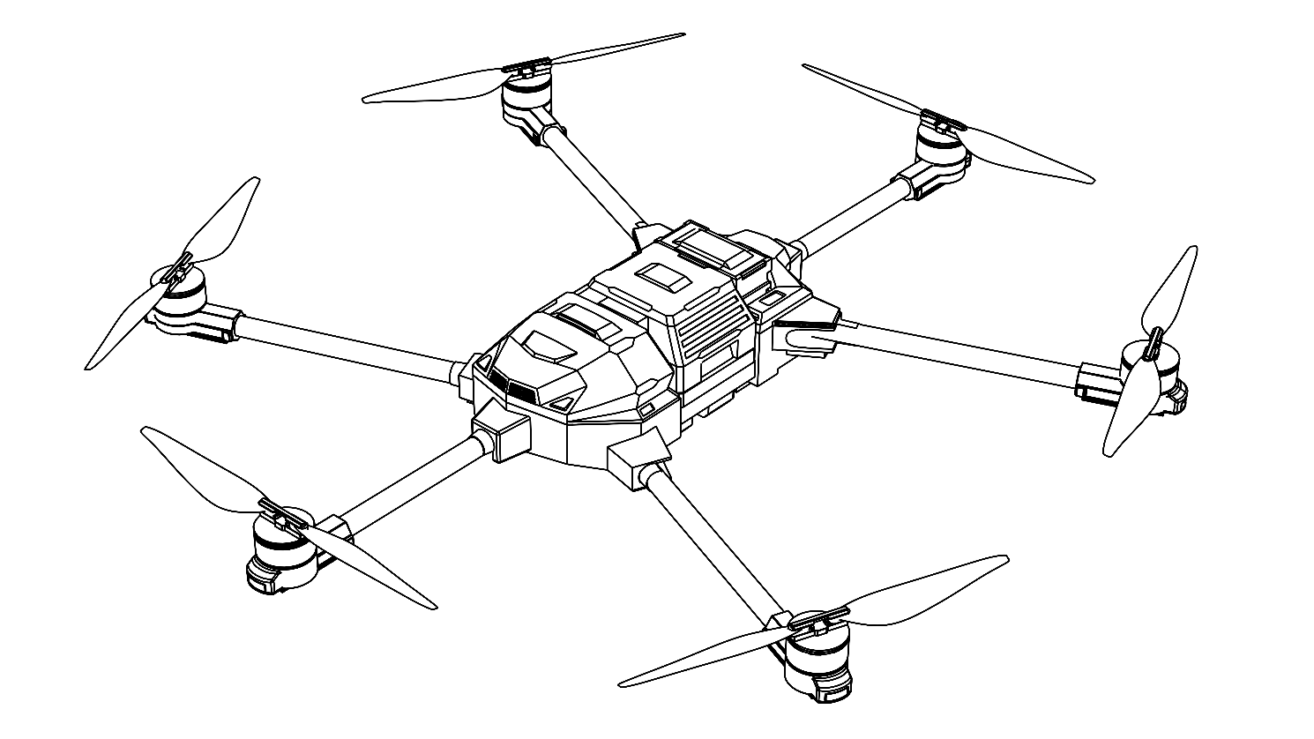

|  |
| --- |
| <https://arc.delivery> |

Table of Contents

1 PREFACE 1

1.1 About the Company 1

1.2 About the Documentation 1

2 OVERVIEW 2

3 FIRST TIME USE 3

3.1 Prepare the Remote Controller 3

3.1.1 Remote controller charging 3

3.1.2 Power on/off 3

3.1.3 Unfold the antenna 4

3.2 Prepare the Aircraft 5

3.2.1 Intelligent flight battery charging 5

3.2.2 Unfold the aircraft 5

3.2.3 Installing the intelligent flight battery 5

4 PART NAME 7

4.1 Aircraft 7

4.2 Remote Controller 7

4.2.1 Ground Unit 7

4.2.2 Air Unit 12

4.2.3 Wiring diagram 13

5 FLIGHT SAFETY 14

5.1 Flight Environment Requirements 14

5.2 Pre-Flight Inspection 14

5.2.1 Remote controller 14

5.2.2 Aircraft 15

5.2.3 Battery 15

5.2.4 Power system 16

5.2.5 Gimbal camera 16

5.3 Calibration of Electronic Instruments 16

5.3.1 Gyroscope calibration 16

5.3.2 Level calibration 17

5.4 Basic Flight 17

6 AIRCRAFT 18

6.1 Automatic Return to Home 18

6.1.1 Intelligent RTH 18

6.1.2 Low-battery RTH 18

6.1.3 Runaway RTH 18

6.2 Low Battery Protection 19

6.3 Emergency Procedures 19

6.3.1 Stopping the motor in mid-air 19

6.3.2 Runaway 19

6.3.3 Alternate landing 19

6.4 Aircraft Indicator 19

6.5 Propeller 20

6.6 Gimbal Camera 21

7 REMOTE CONTROLLER 22

7.1 Overview 22

7.2 Technical Parameters 22

7.2.1 Remote Controller (Ground Unit) 22

7.2.2 Air Unit 22

7.3 Data flow connection diagram 24

7.4 Remote Controller Operation 25

7.4.1 Power on/off 25

7.4.2 Charging 26

7.4.3 Charging indicator definition 26

7.5 Remote Controller Status Indicator 26

7.5.1 Remote Control Status Indicator 26

7.5.2 Air Unit Indicator 27

7.6 Improve Communication Range and Video Fluency 27

7.6.1 General precautions 28

7.6.2 General antenna options and wireless mode configuration for different range 28

7.6.3 How to place the long-range patch antennas on Ground Unit 28

7.6.4 How to place Air Unit antennas 28

8 INTELLIGENT FLIGHT BATTERY 30

8.1 Overview 30

8.2 Battery charging 30

8.2.1 Procedure 31

8.2.2 Storage charger 31

8.2.3 Indicator status display 32

8.2.4 Except information 32

8.3 Battery storage 32

8.4 Battery transportation 33

8.5 Battery maintenance 33

8.6 Battery Disposal 34

9 MANUAL DELIVERY 35

9.1 Overview 35

9.2 Steps 35

10 AUTOMATIC DELIVERY 35

10.1 Overview 35

10.2 Steps 35

APPENDIX1 SPECIFICATIONS 38

APPENDIX2 AFTER-SALE SERVICE 43

CONTACT US 46

**UPDATE LOG**

|  |  |
| --- | --- |
| Version | Updates |
| V1.0 | First Draft |

# PREFACE

## About the Company

ARC is a trademark of ARC UAS, Inc. (abbreviated as “ARC”) and its affiliated companies. Names of products, brands, etc., appearing in this document are trademarks or registered trademarks of their respective owner companies. This product and document are copyrighted by ARC with all rights reserved. No part of this product or document shall be reproduced in any form without the prior written consent or authorization of ARC. This document and all other collateral documents are subject to change at the sole discretion of ARC. This content is subject to change without prior notice. For up-to-date product information, visit <https://arc.dilivery>***/***

## About the Documentation

ARC provides users with the following documentation:

* *List of items*
* *Disclaimer and Safety Guidelines*
* *User Manual*

It is recommended that the user use the " List of Items" to check to ensure that the parts are consistent with the list. First, please read the "Disclaimer and Safety Guidelines", and then follow the "Installation Manual" to complete the installation and understand the use process. Please refer to the User Manual for details. Before using this product, please make sure that you are familiar with the functions and operation methods of each component, and if you have any questions when using this product, please contact ARC or ARC's authorized agent for technical support.

# OVERVIEW

Airis3 is a multi-functional intelligent drone with the characteristics of large load capacity, long endurance, high strength and small size. Airis3 is an integrated fuselage frame with a simple structure. The fuselage and arms are made of carbon fiber materials. While ensuring strength, it also has the advantage of lightweight fuselage. When not in use, the six arms can be cross-layered and folded to reduce the volume and facilitate transportation. After the arms are opened, there are high-strength locks to self-lock the arms, which provides a strong safety guarantee for the stability of Airis3 and makes the flight posture more stable.

Airis3 adopts a three-stage fuselage layout design, with the flight control in the front, the delivery device in the middle, and the battery in the back. It has a delicate structure and unique shape. The plug-in dropper and vertical battery design allow for quick battery replacement, which is easy and efficient to operate. All parts can be quickly disassembled and replaced for easy maintenance.

The Airis3 has a takeoff weight of 29 kg, a maximum flight speed of 43 kilometers per hour, and an empty flight time of 35 minutes. After the drone is turned on and waits for a few minutes, it can take off after the GPS satellite positioning is completed. In order to take into account the usage scenarios of different customers, the Airis3 has two flight modes:

1. **Manual mode**: Use the remote control to operate the Airis3 to complete flight, delivery and other tasks.
2. **Automatic mode**: Set the take-off and landing points in the software, click Start, wait a few seconds, and Airis3 will automatically perform take-off, delivery, return, landing and other tasks.

# FIRST TIME USE

## Prepare the Remote Controller

### Remote controller charging

Use the provided PD 20W charger to charge the remote controller. The power indicator light turns green to indicate charging is complete, and red to indicate charging is in progress.



Note:

Please keep the remote control turned off before charging.

### Power on/off

Press the power button once, then press and hold to power on the remote controller; press and hold the power button to turn off the remote controller.

After turning on the remote controller for the first time, you need to activate the remote controller according to the interface prompts.



### Unfold the antenna

Please tighten the SMA connection between the antenna and the remote controller, unfold the remote controller antenna and adjust it to a suitable position.



## Prepare the Aircraft

### Intelligent flight battery charging

The Intelligent Flight Battery must be charged using the intelligent charger provided by ARC. For the first time charging, please refer to the detailed instructions in Section 8.3 of this document.

### Unfold the aircraft

1. Remove the propeller holders on the M1 and M2 arms.
2. First unfold the M1 and M2 arms, then unfold the M3 and M5 arms, and finally unfold the M4 and M6 arms, and lock the buckles of the arms.
3. Unfold the propellers.



### Installing the intelligent flight battery

Install the intelligent fight battery as shown. Make sure the battery is balanced and installed properly.



# PART NAME

## Aircraft



## Remote Controller

### Ground Unit

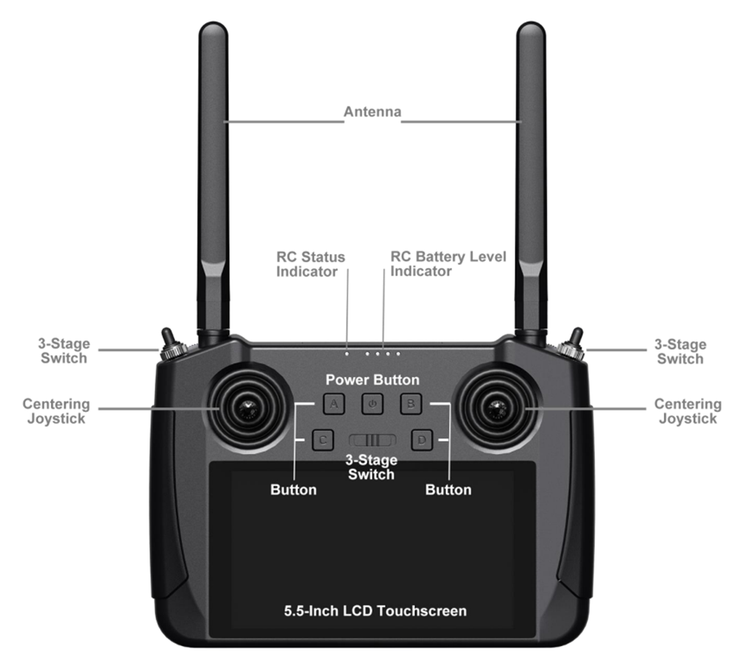



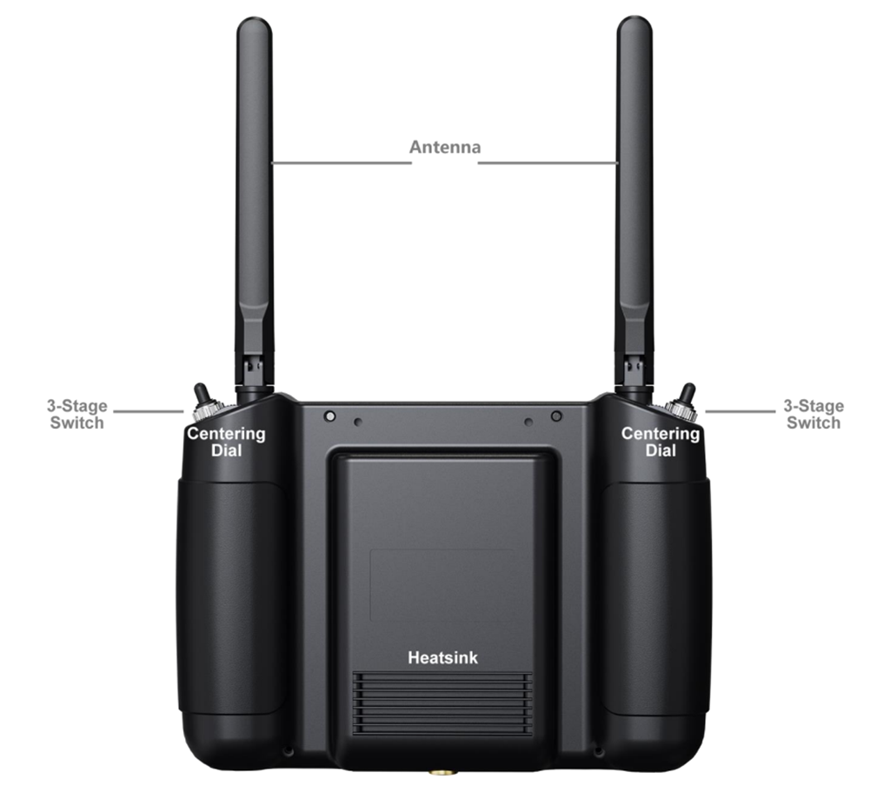





### Air Unit

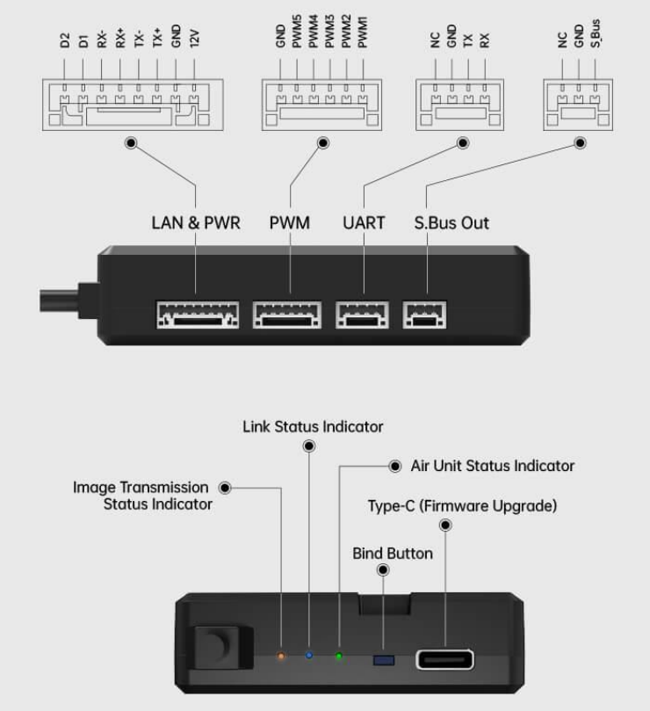

### Wiring diagram

# FLIGHT SAFETY

Please complete flight training before flying, such as learning at a flight training center, practicing with a software simulator, or receiving guidance from professionals. Please select a suitable flight environment according to the following flight requirements and restrictions before flying and pay attention to local laws and regulations to fly legally. Please be sure to read the “Disclaimer and Safety Guidelines” before flying to understand safety precautions.

## Flight Environment Requirements

1. Do not fly in bad weather conditions, such as strong winds (wind speed 12 m/s or above), heavy rain (rainfall of more than 25 mm in 24 hours), heavy snow, fog, etc.
2. When flying, please keep the controls within your sight and keep the aircraft at least 10 meters away from obstacles, people, water surfaces and other objects.
3. Do not operate the aircraft indoors.
4. In low temperature (0°C to 10°C) environment, please ensure that the aircraft battery is fully charged and reduce the aircraft load, otherwise it may affect flight safety.
5. Please make sure to operate the aircraft in an open area.
6. To prevent the remote control from interfering with other wireless devices, be sure to turn off other wireless devices in the same frequency band before using the remote control.
7. If you use multiple aircraft at the same time, please ensure that the distance between each aircraft is more than 10 meters to avoid mutual interference.
8. Please be careful when flying and avoid getting close to electromagnetic interference (such as high-voltage power lines, high-voltage transmission stations, television broadcast towers, etc.). When flying in the above places, the performance of the aircraft may be interfered with. If the interference source is too large, the aircraft will not be able to fly normally.

## Pre-Flight Inspection

### Remote controller

To avoid possible damage and loss, the following points must be observed:

1. Use each part of the interface strictly according to the interface definition.
2. Please make sure the remote control is connected to the Internet (via Wi-Fi or cellular network), otherwise the flight records cannot be uploaded. If you cannot provide the flight records to our ARC, ARC will not be able to analyze the cause of your product damage or accident, nor can it provide you with after-sales service.
3. Please make sure the battery is fully charged before each flight.
4. Adjust the antenna to the appropriate position for optimal communication.
5. If you find that the antenna is damaged, please contact ARC technical support for repair.
6. Replacing the remote control requires binding. Please refer to the user manual for specific operations.
7. Charge and discharge the battery every 3 months to extend the battery life.
8. When the battery level of the remote control is 0%, please charge it in time to prevent the battery from over-discharging and damaging the device due to long-term low-power storage. When not in use for a long time, please charge the battery to about 40% - 60% for storage.
9. Do not cover the heat sink of the remote control to avoid overheating the remote-control during operation and affecting its performance.

### Aircraft

To avoid possible damage and loss, the following points must be observed:

1. Use each part of the interface strictly according to the interface definition.
2. Do not short-circuit the interfaces on the aircraft body.
3. When preparing the aircraft (such as assembling, debugging, wiping, etc.), you must be careful to avoid injury.
4. When unfolding the arms, please fold them in order of M1 and M2 arms, then M3 and M5 arms, and finally M4 and M6 arms. When folding the arms, please fold the arms in the order of M1 and M2, then M4 and M6, and finally M3 and M5 arms, and clip the arms into the fixed frame on the side of the aircraft and secure them with the propeller holders, otherwise the arms may be damaged.
5. Do not block the video transmission antenna.
6. There are waterproof covers on many places on the drone body, so be sure to cover the waterproof covers when not in use to prevent water from entering and causing a short circuit.

### Battery

To avoid possible damage and loss, the following points must be observed:

1. Always use the specified type of battery recommended by ARC.
2. The maximum allowable voltage of the aircraft is 52.2V, please use it in strict accordance with the relevant safety regulations and the instructions of the battery itself and be sure to pay attention to safety.
3. Never rinse the battery with water.

### Power system

To avoid possible damage and loss, the following points must be observed:

1. Always check the integrity of each propeller before each flight. If you find that the propeller is aged, damaged or deformed, please replace it before flying.
2. Make sure the power remains off when performing any operation on the propeller.
3. The propeller blades are thin, so please be careful when operating them to avoid accidental scratches.
4. Before each flight, please check whether the propellers are installed correctly, tightened, and unfolded.
5. Keep away from rotating propellers and motors to avoid being cut.
6. Make sure the motor is securely mounted and can rotate freely.
7. Do not modify the physical structure of the motor by yourself.
8. After the motor stops rotating, do not touch the motor with your hands immediately to avoid burns.
9. Do not cover the motor exhaust port.

### Gimbal camera

1. The gimbal contains precision parts. If they are hit or damaged, the gimbal performance may be damaged and degraded. Please keep the gimbal properly to avoid physical damage.
2. Do not apply external force to the gimbal while it is working.
3. Do not add other devices or objects to the gimbal, as this will affect the performance of the gimbal.

## Calibration of Electronic Instruments

### Gyroscope calibration

1. Open the XXX app and click XXX.
2. Flip the aircraft as shown in the figure until there is a "beep" sound, and then calibrate the next posture.
3. When all six postures are calibrated, XXX appears on the screen, indicating that the calibration is complete.
4. If the calibration fails, recalibration is required.

### Level calibration

1. Open XXXX app and click XXX.
2. Place the aircraft horizontally. When the screen displays XXX, the calibration is complete.
3. If the calibration fails, recalibration is required.

Note:

The calibration of electronic instruments is very important. The calibration results directly affect flight safety. Calibration failure may cause the aircraft to malfunction.

Try to place the aircraft on a flat ground or surface so that the calibration results will be more accurate.

## Basic Flight

1. Place the aircraft near the work area.
2. Turn on the remote controller, then turn on the aircraft.
3. Make sure the aircraft is properly connected to the remote controller and the GPS is properly connected.
4. Push the throttle stick upwards to let the aircraft take off smoothly.
5. When you need to descend, you can manually control the aircraft and slowly pull down the throttle stick to make the aircraft slowly descend on flat ground.
6. After landing, pull the throttle lever to the lowest position and hold it until the motor stops.
7. After stopping, turn off the aircraft first, and then turn off the remote control.

# AIRCRAFT

The aircraft is mainly composed of a flight control system, communication system, power system, delivery system and an intelligent flight battery.

## Automatic Return to Home

The aircraft has an automatic return function, which is mainly divided into intelligent return, low battery return, and runaway return according to the return trigger method.

### Intelligent RTH

During the intelligent return process, the heading is uncontrollable. When XXXX, the user can regain control of the aircraft.

**Intelligent RTH process**

1. XXXX
2. XXX

### Low-battery RTH

If XXX has set low-battery return, the aircraft will automatically enter the return process when the battery power reaches the power threshold.

During the intelligent return process, the heading is uncontrollable. When XXXX, the user can regain control of the aircraft.

### Runaway RTH

If XXXX occurs and the flight control system works normally, after successfully recording the return point, the flight control system will control the aircraft to fly back to the most recently recorded return point.

**Runaway RTH process**

1. XXXX
2. XXX

## Low Battery Protection

The real-time power level of the Intelligent Flight Battery is displayed on the remote controller, and users can set the low-battery voltage alarm threshold in the remote controller.

When a low battery warning appears, fly the aircraft to a safe area and land as soon as possible, then replace the battery.

## Emergency Procedures

### Stopping the motor in mid-air

If you encounter special circumstances, such as the possibility of an aircraft crashing into a crowd, you can stop the motor immediately to minimize damage. Stopping the motor during flight will cause the aircraft to crash.

### Runaway

When the link is lost in manual mode, the flight control system will control the aircraft to fly back to the most recently recorded return point.

### Alternate landing

When the aircraft's landing point is far from the return point, or the aircraft does not need to return to the return point, you can set an alternate landing point to deal with low battery or other abnormal situations.

## Aircraft Indicator

The aircraft arms, M1 to M6 are equipped with LED lights. The LED on the M1 arm is the nose indicator light, which is off during flight; the LED on the M2 arm is the tail indicator light, which indicates the tail direction in white during flight; the LEDs on the M3 and M5 arms are the left side indicator lights, which indicate the left direction in red during flight; the LEDs on the M4 and M6 arms are the right side indicator lights, which indicate in green during flight.



## Propeller

The aircraft is equipped with 2480 carbon plastic propellers. The blades have two specifications: CW and CCW. They must be installed on the CW and CCW motors respectively, otherwise it will cause flight failure or even failure to take off. When replacing the blades, please replace them in pairs.

* Please use the propellers provided by ARC. Do not mix different types of propellers.
* Propellers are consumable, please purchase them separately if necessary.
* Before each flight, please check whether the propeller is installed correctly and tightened, and check whether the propeller gasket is worn.
* Always check each propeller to see if it is in good condition before each flight. If a propeller is aged, damaged, or deformed, replace it before flying.
* Stay away from the rotating propellers and motors to avoid cuts.
* Since the propeller blades are thin, please handle them with care to prevent accidental scratches.



## Gimbal Camera

The aircraft is equipped with a A2mini ultra-wide-angle FPV gimbal, which can help users observe the flight environment in real time during flight.

The lens adopts a horizontal 160-degree ultra-wide-angle design and has a distortion correction algorithm, which makes the image under ultra-wide-angle display natural. The gimbal has an IP65 triple-proof design, making user use and maintenance more convenient and reliable.

# REMOTE CONTROLLER

## Overview

The control scheme includes remote control, data, and image transmission links in one, and has adaptive frequency band characteristics, which can switch to the working frequency band with the least interference. The handheld ground station is equipped with a 5.5-inch 1080P resolution high-definition high-brightness display with a maximum brightness of 1000 nits (cd/m²). It can still clearly present ground station information and high-definition image transmission pictures under direct sunlight outdoors. The remote control is equipped with Qualcomm's octa-core high-performance CPU, which can easily hard-decode H.264/H265 and 1080P 60 frame video streams and can run various ground station software at high speed.

## Technical Parameters

### Remote Controller (Ground Unit)

|  |  |
| --- | --- |
| Display Device | 5.5-inch 1080P HD high-brightness LCD touch display |
| System Configuration | Android 9.0 2G RAM, 16G storage |
| Dimensions (Antenna Folded) | 189 x 138 x 41 mm |
| Weight | 850 g |
| Battery Capacity and Type | 10200 mAh 7.4V 2S Lithium-ion batteries |
| Fast Charging Protocol | PD 20W |
| Charging Time | 5 hours (20W fast charging) |
| Continuous Working Battery Life | 13 hours |
| Functional Interfaces | Video output: Standard HDMI  External device: USB-A  Charging: Type-C  Firmware upgrade: upgrade port (bottom GH1.25 4Pin)  File Transfer: Type-C / USB-A  Mobile network: SIM card slot  External Storage: TF card slot / USB-A  Tripod fixation: 1/4 threaded hole |
| Waterproof Rating | IP53 |
| Operating Ambient Temperature | -10° C to 50° C (-4° to 122° F) |

### Air Unit

|  |  |
| --- | --- |
| Signal Output | 16-channel S.BUS  5-channel PWM |
| Operating Voltage | 14 to 58.8 V |
| Functional Interfaces | Remote Control Signal Output: S.BUS (GH1.25 3-Pin)  Data Transmission (Connected to Flight Controller): UART (GH1.25 4-Pin)  PWM channels 1-5: GH1.25 6-pin  Video Input/Ethernet Data Communication: Ethernet Port (GH1.258-Pin)  Firmware upgrade: Type-C |
| Dimensions (without Antenna) | 70 x 55 x 16 mm (with fan height) |
| Weight (without Antenna) | 100 g (with buck module) |
| Antenna Gain | Omnidirectional antenna: 5 dBi |
| Operating Ambient Temperature | -10℃~ 50℃(-4° to 122° F) |

## Data flow connection diagram

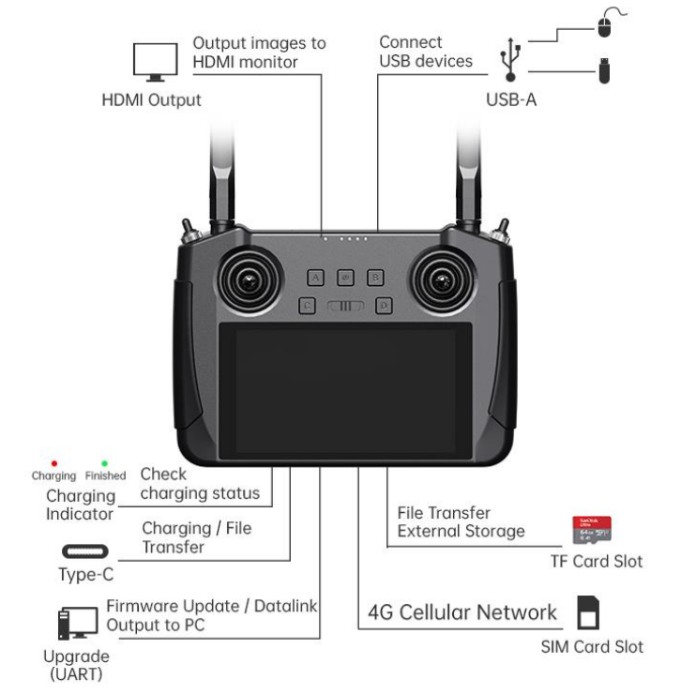

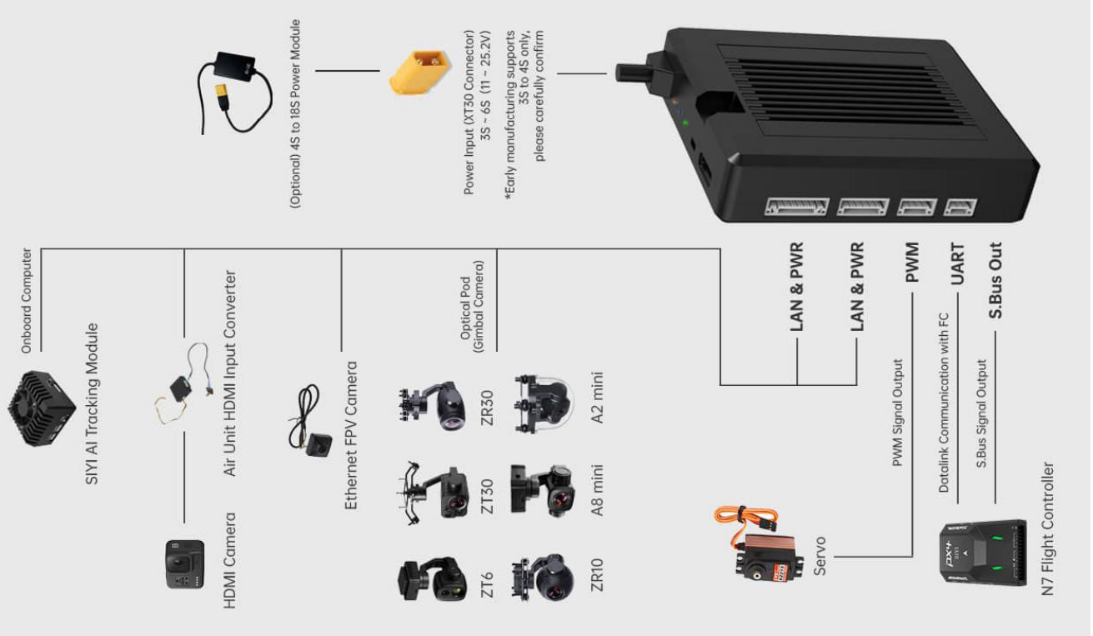

## Remote Controller Operation

### Power on/off

* Power on: When the remote control is powered off, short press the power button for about 1 second and the battery indicator lights up. Then long press the power button for about 2 seconds and wait for the battery indicators to light up one by one to turn on the remote control and enter the working state.
* Power off: When the remote control is turned on, press and hold the power button for about 2 seconds. A pop-up window will appear on the system interface. Touch the power off icon to turn off the remote control.
* Forced shutdown: When the remote control is powered on, press and hold the power button for about 8 seconds to force the remote control to shut down.

### Charging

The remote control can only be charged using the original standard charger when it is turned off.

* Use the Type-C fast charging cable to connect the remote control and the PD fast charging plug.
* If you observe that the charging indicator light is solid red, it means it is charging.
* When the charging indicator lights up solid green, charging is complete.

Note:

The remote controller cannot be charged with a 5V charger, please use the original fast charger.

The remote control cannot be charged when it is powered on. Please make sure it is powered off before charging.

### Charging indicator definition

Solid red light: Charging

Solid green light: Charging completed

## Remote Controller Status Indicator

### Remote Control Status Indicator

* Solid Red: No communication between ground unit and air unit.
* Fast Red Blinks: Ground unit is binding to air unit.
* Slow Red Blinks: Ground unit firmware does not match air unit firmware.
* Triple Red Blinks: System initialization failed.
* Four-time Red Blinks: Joysticks require calibration.
* Red-Green Blinks: Android system unexpected power off.
* Slow Red-Green-Yellow Blinks: Image transmission system is starting.
* Fast Red-Blue-Yellow Blinks: Firmware is updating.
* Slow Yellow Blinks: Ground unit voltage abnormal.
* Double Yellow Blinks: Ground unit Bluetooth is not identified.
* Triple Yellow Blinks: Transmission system data overload alert, level one.
* Slow Yellow Blinks: Transmission system data overload alert, level two.
* Yellow-Red Blinks: Ground unit high-temperature alert, level one.
* Yellow-Red-Red Blinks: Ground unit high-temperature alert, level two.
* Yellow-Red Blinks: Transmitter high-temperature alert, level three.
* Solid Green: Perfect communication, receiving 100% data package.
* Green Blinks: Blinking frequency indicates the system’s signal quality. More frequently it blinks, worse the signal quality is.
* Slow Green Blinks (1 Hz): Receiving 95% to 99% data package.
* Green Blinks (every 3/5 second): Receiving 50% to 75% data package.
* Green Blinks (every 3/10 second): Receiving 25% to 50% data package.
* Green Blinks (every 1/25 second): Receiving less than 25% data package.
* Blue-Red Blinks: Air unit overheat alert, level one.
* Blue-Red Blinks: Air unit overheat alert, level two.
* Blue-Red Blinks: Air unit overheat alert, level three.

### Air Unit Indicator

* Solid Red: No communication between ground unit and air unit.
* Fast Red Blinks: Air unit is binding to ground unit.
* Slow Red Blinks: Air unit firmware does not match ground unit firmware.
* Triple Red Blinks: System initialization failed.
* Slow Red-Green-Yellow Blinks: System is starting.
* Fast Red-Green-Yellow Blinks: Firmware is updating.
* Yellow Blinks: Air unit low voltage alert (voltage input lower than 12V).
* Solid Green: Perfect communication, 100% data package received.
* Green Blinks: Blinking speed indicates the system’s signal strength. More frequently it blinks, the worse the signal quality is.
* Slow Green Blinks (1 Hz): 95% to 99% data package received.
* Green Blinks (every 3/5 second): 50% to 75% data package received.
* Green Blinks (every 3/10 second): 25% to 50% data package received.
* Green Blinks (every 1/25 second): less than 25% data package received.
* Fast Green-Red Blinks: Air unit starts to bind wirelessly (plug power three times to trigger).
* Green-Red Blinks: Air unit overheat alert, level one.
* Green-Red-Red Blinks: Air unit overheat alert, level two.
* Green-Red-Red-Red Blinks: Air unit overheat alert, level three.

## Improve Communication Range and Video Fluency

For optimal communication range and video quality, please read the following tips carefully regarding antenna options, antenna settings, and link configuration.

### General precautions

1. It is suggested that not to run QGroundControl app only with video streaming, not even running one at backstage.

### General antenna options and wireless mode configuration for different range

1. **0 to 8 Kilometers Range:**

Two standard omni antennas on ground unit.

Wireless mode: 5 km or 8 km low latency.

1. **8 to 15 Kilometers Range:**

Two standard omni antennas or two standard long-range antennas on ground unit.

Wireless mode: 15 km GCS.

1. **15 to 24 Kilometers GCS Flight**

Two standard long-range antennas or higher gain patch antennas on ground unit.

Wireless mode: 24 km GCS.

1. The signal at the top of the standard omnidirectional antenna is weak. When flying directly above the ground, the flying height of the aircraft should be as low as 100 meters.
2. When the ground unit is working with long range antennas or patch antennas, the aircraft should always be in front of the antenna panel instead of being vertical of the antenna or on opposite.

### How to place the long-range patch antennas on Ground Unit

1. The SMA connectors should be screwed tightly.
2. Long-range patch antennas are directional, which should always be pointing to the aircraft during flight.
3. When you are using standard long-range antennas, please make its short side be parallel with horizon and its long side be vertical of the control panel to get the best signal quality.

### How to place Air Unit antennas

1. The SMA connectors should be screwed tightly.
2. On multirotor, the standard omni antennas should be hanging vertically from the drone arms with the antenna heads pointing to ground, and the antenna flat side should always point to the ground unit during flight. On planes, the standard omni antenna can stand vertically above the wings, and the antenna flat side should always point to the ground unit during flight.
3. The air unit antenna feeder wire should be placed away from E.S.C and motors, and any other equipment with heavy current or interference. Do not cross or overlap the antenna feeder wires.
4. The antenna body, feeder wire, and the SMA connectors should not touch the metal / carbon-fiber structure parts directly. Please reserve at least 10 mm distance between these parts and the structure parts.
5. The two air unit antennas should be placed away from each other for at least 50 mm distance. And try your best to avoid any kinds of obstruction between the ground unit and the aircraft during flight.
6. Please be very careful with the antenna wire’s SMA connectors and its solder connectors. Do not drag them or bend them in case of any damage. To adjust the position of the antenna, please always try to bend the middle part of the antenna feeder wires.

# INTELLIGENT FLIGHT BATTERY

## Overview

The intelligent flight battery is assembled from high-quality, high-performance high-voltage lithium cells. The nominal voltage of the cell is 3.8V, the energy density is over 200Wh/kg, it supports 3C fast charging customization, and uses a stacking process, which has a smaller internal resistance and better charging and discharging efficiency.

## Battery charging

The four-channel smart charger is a smart charger that integrates a charger and a charging manager and can connect 4 batteries. The charger has a maximum output power of up to 2500W and has two modes of fast charging and slow charging for users to choose from.

During the charging process, the charger can communicate with the battery and intelligently adjust the charging current according to the current acceptable current size of the current battery condition. In addition, this charger is easy to operate, safe and reliable, and has functions such as overcurrent protection, overcharge protection, overtemperature protection and status indication.

### Procedure

Before using the charger, please make sure that the charger is grounded through the grounding wire and use it strictly according to the instructions. The charger can connect to 4 batteries. Please use this product as follows.

1. Power on: Connect the AC power supply, turn on the power switch, the charger will beep, and the fan will rotate once.
2. Connect the battery: Please connect the battery and charger as shown below:

Note:

12-cell and 14-cell batteries cannot be charged together. Select the slow charge/fast charge mode, press and hold the "Start/Stop" button for 3 seconds to start charging.

Shortly press the "Start/Stop" button to stop or release the abnormal state.

### Storage charger

When charging is complete or the charger is not in use, disconnect the battery charging cable from the battery and the power cord, and cover the battery charging port protective cover to prevent the main charging port from being oxidized. Store the charger in a cool and dry place for protection.

### Indicator status display

|  |  |  |
| --- | --- | --- |
| Channel indicator light  (green light) | Battery detected | The corresponding channel’s average voltage is <4.05V per section and the orange light is always on |
| The corresponding channel average voltage per section> 4.05V green light is always on |
| Charging | The green light of the corresponding channel flashes |
| Charging completed | The corresponding channel green light is always on |
| Mode indicator light  (green light) | Standby | The corresponding mode light is always on |
| Charging begins, processes, and is completed | The corresponding mode light flashes |

### Except information

|  |  |  |
| --- | --- | --- |
| Abnormal indicator light and warning sound | All channel lights flash red, and the mode light is always on | The voltage of the main port is too low or too high (one beep between prompts) |
| Communication interruption (two beeps between prompts) |
| The temperature is too high, the power supply or battery (three beeps between prompts) |
| AC input is out of range (four beeps between prompts) |
| Others The number of batteries mixed (five beeps between prompts) |

## Battery storage

Appropriate storage power can extend battery life. It is recommended to keep the power at 30% or above during long-term storage and charge the battery at least once every 5 months to avoid over-discharge.

1. Do not store the battery at room temperature above 45°C or below -20°C. If the battery is stored for a long time (more than three months), it must be placed in an environment with a temperature of -20°C to 40°C. The battery needs to be disconnected from the aircraft. It is recommended to use a special explosion-proof box for the battery. Long-term high-voltage storage will shorten the battery life.
2. Do not store the battery for a long time after it is completely discharged to avoid the battery entering an over-discharge state, causing damage to the battery cell and making it impossible to restore it to use.
3. Please keep the battery out of the reach of children. If a child accidentally swallows a part, seek medical help immediately.
4. If the battery is left idle for a long time, its performance will be affected.
5. Recharge and discharge the battery every 3 months to maintain battery activity.

## Battery transportation

After each use, disconnect the aircraft from the battery and check whether there is any debris in the battery power interface. If there is any, please clean it up in time.

1. During transportation, please ensure that the battery is disconnected from the aircraft or other equipment.
2. If the battery is seriously low at the end of the flight, you need to charge it to about 25% before storing it. Otherwise, long-term storage may cause damage to the battery.
3. The environment where the battery is stored should be kept dry. Do not place the battery in water or in places where water may leak.
4. It is prohibited to store or transport batteries together with metal objects or flammable and explosive items.
5. Do not transport damaged batteries or batteries with a charge level higher than 30%. Please discharge the battery to about 25% before transporting.
6. When placing the battery, make sure the ground is flat to prevent sharp objects from damaging the bottom of the battery.

## Battery maintenance

To minimize the effects of battery aging on performance, it is recommended that the following be performed on the battery every 200 cycles or every 3 months:



## Battery Disposal

Please follow the steps below to dispose of the battery:

* Before disposing, make sure to soak the battery in water for 72 hours to completely discharge the battery. Dispose of the battery in specific battery recycling boxes. The battery contains hazardous chemicals, DO NOT dispose of the battery in a regular waste disposal container. Strictly follow your local regulations regarding the disposal and recycling of batteries.
* If the battery cannot be discharged completely, DO NOT dispose of the battery in a battery recycling box directly. Contact a professional battery recycling company for assistance.

# MANUAL DELIVERY

## Overview

Airis3 supports manual delivery. Before using this function, to avoid safety issues and unnecessary losses, please make sure you are proficient in operating the aircraft.

## Steps

1. Ensure that the take-off and landing point is open, the ground is flat, and there is no debris within a 2.5 meters radius of the take-off and landing point.
2. Please connect the battery to the aircraft and wait for a few minutes to ensure that the remote controller, GPS, and aircraft are connected normally.
3. Press the Relax button on the remote control, the delivery hook will be released, please hang the goods on the delivery hook.
4. Press the Load button, and you can see the delivery hook being pulled tight into the delivery box.
5. Personnel quickly evacuate to a safe area (10 meters), and the operator controls the drone to fly to the designated location for delivery.
6. When arriving at the delivery area, put the drone in a hovering state and press the Delivery button. The delivery hook is released and the cargo lands. After the cargo lands, the hook will automatically retract.
7. The operator controls the drone to the designated landing location.

# AUTOMATIC DELIVERY

## Overview

Automatic transportation and delivery can realize a series of tasks such as aircraft take-off, delivery, return, and landing, greatly improves work efficiency.

## Steps

1. Ensure that the take-off and landing points are open, the ground is flat, and there are no debris within a radius of 2.5 meters from the take-off and landing points.
2. Please connect the battery to the aircraft and wait for a few minutes to ensure that the remote controller, GPS, and aircraft are connected normally.
3. Press the Relax button on the remote control, the delivery hook will be released, please hang the goods on the delivery hook.
4. Press the Load button, and you can see the delivery hook being pulled tight into the delivery box.
5. Personnel quickly evacuate to a safe area (10 meters).
6. Open the ARC CONTROL ROOM application on your browser, click XXXXXX, set XXXX, and click Start.
7. After waiting for 2 seconds, the drone will automatically take off and fly along the specified path.
8. When arriving at the delivery area, the delivery hook is released and the goods land. The hook will automatically retract after the goods land.
9. The drone returns to the designated landing area.

**This page is intentionally left blank**

# APPENDIX1 SPECIFICATIONS

**Unmanned Aircraft (UA)**

|  |  |
| --- | --- |
| Maximum Gross Takeoff Weight | 58.4lbs (26.5kg) |
| Max Payload | 17.6lbs (8kg) |
| Weight | 29.4lbs(without battery)  13.4kg(without battery)  40.7lbs (with battery)  18.5kg(without battery) |
| Dimensions | 71.8 x 74.1 x 23.6 in (unfolded)  1823 x 1882 x 600mm (unfolded)  30.1 x 20.1 x 23.6 in (folded)  765 x 510 x 600mm (folded) |
| Maximum Flight Speed | 35.8mph (16m/s) |
| Max Flight Time | 25min[1] (16000mAh)  35min[2] (25000mAh) |
| Wheelbase of the Drone Rack | 57.5in (1460mm) |
| Supply voltage | 12S |
| Auto-Landing accuracy | 1ft (30cm) |
| Maximum Space Required to Launch UA | 6 ft x 6 ft |
| Max Celling | ft (3000m) |
| GNSS | GPS |
| IMU | Triple Redundancy |
| Operating Temperature | 0 to 110° F (-17.8° C to 43.3° C) |
| Wind Resistance | 25 mph (11.2m/s) |
| Flight Range | 12.4mile (20km) |
| Water Resistance | IP54 |

**Power system**

|  |  |
| --- | --- |
| Max Thrust | 26.0lbs/Axis (46V, Sea Level)  11.8kg/Axis (46V, Sea Level) |
| Thrust/Rotor | 7.7-12.1lbs/Axis (46V, Sea Level)  3.5-5.5kg/Axis (46V, Sea Level) |
| Recommended Battery | 12-14S |
| Operating Temperature | -4° F to 122° F (-20° C to 50° C) |
| Motor KV Rating | 150rpm/V |
| Motor Stator Size | 2.4 x 0.7in (62 x 18mm) |
| Motor Powertrain Arm Tube Outer Diameter | 1.2in (30mm) |
| Motor Bearing | Waterproof |
| Propellers Material | Carbon fiber composite |
| ESC PWM Input Signal Level | 3.3V/5V |
| ESC Throttle Signal Frequency | 50-500Hz |
| ESC Operating Pulse Width | 1050-1950us (Fixed or cannot be Programmed) |
| ESC Max Input Voltage | 61V |
| ESC Max Input Current (Short Duration) | 80A (Non-hermetic Ambient Temperature 60°C) |

**Delivery Winch System**

|  |  |
| --- | --- |
| Winch weight | 5.5lbs (2.5kg) |
| Max Delivery Weight | 17.6lbs (8kg) |
| Max Delivery Height | 1574.8in (40m) |
| Tether Rated Tensile Strength | 100 kg (220.5lbs) |
| Payload Release | Auto-Release or Manual-Release via web application settings or remote controller. |

**Ground Unit**

|  |  |
| --- | --- |
| Monitor Display | 5.5-inch 1080p High Definition and High Brightness LCD Touchscreen |
| System | Android 9.0 OS, 2G RAM, 16G ROM |
| Battery Capacity & Type | 10200 mAh 7.4V 2S Li-ion 75.48 Wh |
| Fast Charging Protocol | PD 20W |
| Charging Time | 5 hours (PD 20W) |
| Battery Life | 13 hours |
| Antenna Gain | Omni Antenna: 5 dBi  Long Range Antenna: 11 dBi (included in enterprise edition)  Lollipop Antenna: 5 dBi (optional) |
| Interface & Ports | Video Output: Standard HDMI *Enterprise edition only  External Device (Mouse, USB Disk): USB-A  Charging: Type-C  Firmware Upgrade: Upgrade Port  File Transfer: Type-C / USB-A  Mobile Network: SIM Card Slot  External Storage: TF Card Slot / USB-A  Tripod Mount: 1/4-inch Standard Screw Hole |
| Dimensions  (Antenna Overlapped) | 7.4 x 5.4 x 1.6in (189 x 138 x 41 mm) |
| Weight  (Battery & Antennas Included) | 1.9lbs (850 g) |
| Waterproof Level | IP53 |
| Operating Temperature | 14° F to 122° F (-10° C to 50° C) |

**Air Unit**

|  |  |
| --- | --- |
| Signal Output | 16 channels of S.Bus  5 channels of PWM |
| Interface & Ports | S.Bus RC Signal Output: S.Bus Out (GH1.25 3-Pin)  Datalink (to FC): UART (GH1.25 4-Pin)  PWM Channel 1 to 5: PWM (GH1.25 6-Pin)  Video Input / Network Communication: LAN & PWR  (GH1.25 8-Pin)  Firmware Upgrade: Type-C |
| Antenna Gain | Omni Antenna: 5 dBi  Lollipop Antenna: 5 dBi (optional) |
| Working Voltage | MK15 Air Unit (included in MK15 agriculture edition):  4S ~ 18S / 16.8 ~ 75.6 V |
| Power Consumption | MK15 Air Unit:  - Average: 3.2 W  - Summit: 12 W |
| Dimensions  (Antenna Excluded) | 2.8 x 2.2 x 0.6 in (fan included)  70 x 55 x 16 mm (fan included) |
| Weight  (Antenna Excluded) | MK15 Air Unit: 0.2lbs (100 g) |
| Operating Temperature | 14° F to 122° F (-10° C to 50° C) |

**Intelligent Flight Battery**

|  |  |
| --- | --- |
| Capacity (mAh) | 16000 |
| Voltage(V) | 44.4 |
| Cells | 12S1P |
| Discharge Rate (C) | 15 |
| Discharge Plugs | AS150U |
| UPC | 889551011204 |
| Weight | 9.1lbs (±0.04lbs)  4141g (±20g) |
| Power | 710.4Wh |
| Maximum Instantaneous Discharge (C) | 30 |
| Wire Specifications | 8# |
| Height | 8.5in (±0.08in)  217mm (±2mm) |
| The Length of the Discharge Wire | 9.1in (±0.08in)  230mm (±2mm) |
| Thickness | 3.1in(±0.2in)  80mm (±5mm) |
| Wide | 5.9in(±0.08in)  150mm (±2mm) |
| Operating Temperature | 50° F to 140°F (10° C to 60° C) |
| Recommended charging temperature | 50° F to 113°F (10° C to 45° C) |
| Maximum continuous discharge current | 100A |
| Maximum charging voltage | 4.2V/cell |
| Recommended landing voltage | 43.2V |
| Recommended forced landing voltage | 42.6V |

**Intelligent Charger**

|  |  |
| --- | --- |
| Input rated voltage/frequency | 100 - 240 V / 50 - 60 HZ |
| Rechargeable battery number | 12S / 14 S |
| Charging current/AC220V | Fast charge: max. 60A single channel  Standard: max. 30A single channel  max. 60A two channels in total  Charge: max. 20A single channel  max. 60A multi channels in total |
| Charging current/AC120V | Fast charge: max. 1200W single channel  Charge: max. 20A single channel  max. 1200W multi channels in total |
| Output power | AC220V: 3000W  AC120V: 1200W |
| Charging mode | Fast charging / Standard Charge/Charge/Storage |
| Weight | 13.2lbs (6kg) |
| Dimensions | 1 x 0.5 x 0.9ft  294mm x 139mm x 282mm |
| Storage Cut-off voltage | 3.8V/Cell |

**A8 mini FPV Gimbal**

|  |  |
| --- | --- |
| Video Output Port | Ethernet, HDMI, CVBS ( AV ) |
| Control Signal Input Port | S.Bus, PWM, Ethernet UDP |
| Control Signal Output Port | S.Bus |
| High-precision three-axis stabilization | Pitch, Heading, Roll |
| Working Voltage Range | 11 - 25.2V |
| Power Consumption | Average: 5 W  Peak: 12 W |
| Operating temperature | 14° F to 122° F (-10° C to 50° C) |
| Dimension | 2.2 x 2.2 x 2.8in (55 x 55 x *7*0 mm) |
| Weight | 0.2lbs (95g) |
| Angle jitter | ± 0.01° |
| Controllable pitch rotation range | -135° to +45° |
| Controllable horizontal rotation range | -160° to +160° |
| Rolling range | -30° to +30° |
| Camera lens | Fixed focus  Six times digital zoom |
| Equivalent focal length | 0.8in (21 mm) |
| Image Sensor | Sony 1/1.7 inches, 8 million effective pixels |
| Aperture | F2.8 |
| FOV | Horizontal 81° |
| TF card video resolution | 4K (4096 x 2160) @ 25 fps  2K (2560 x 1440) @ 30 fps  1080p (1920 x 1080) @ 30 fps  720p (1280 x 720) @ 30 fps |
| Supported file systems | FAT32 |
| Photo file format | JPG |
| Video file formats | MP4 |
| Supported memory card types | MicroSD class10 supports up to 128 GB |
| Photo mode | Single shot |
| White Balance | Automatic |
| IR Capabilities | - |

# APPENDIX2 AFTER-SALE SERVICE

To protect the rights and interests of users, ARC provides users with related services such as repair, exchange and return of related products.

After purchasing ARC products, if the following problems or failures occur and are confirmed to be true by ARC or ARC's dealers, users can enjoy the following services with the purchase receipt or invoice:

**A. Repair Service**

If your purchased ARC products cannot work properly, please contact ARC for consultation.

Usually there are two situations for acquiring repair service.

* Product Defect
* Product Damage

ARC products under the two situations can be sent back to ARC for repairs. Defective products with valid warranty can be repaired for free. Defective products without valid warranty or damaged products should be charged of repair fees after repairing.

**B. Warranty**

**7-Day Return & Refund**

* Within seven (7) days of receiving a product if the product has no manufacturing defect, has not been activated and is still in new or like-new condition.
* Within seven (7) days of receiving a product if the product has a manufacturing defect.

**Return & Refund Service will not be provided where:**

* It is requested beyond seven (7) calendar days of receiving a product.
* A product sent to ARC for Return & Refund Service does not include all original accessories, attachments or packaging, or any item is not in new or like-new condition, i.e., with cracks, dents, or scratches.
* A legal proof of purchase, receipt or invoice is not provided or is reasonably believed to have been forged or tampered with.
* Any fault or damage of the product is caused by unauthorized use or modification of the product, including exposure to moisture, entry of foreign bodies (water, oil, sand, etc.) or improper installation or operation.
* Product labels, serial numbers, waterproof marks, etc. show signs of tampering or alteration.
* Damage is caused to the product by uncontrollable external factors, including fire, floods, high winds, or lightning strikes.
* A product is not delivered to ARC within seven (7) calendar days after Return & Refund Service confirmation is sent from ARC.

**15-Day Replacement**

* Within fifteen (15) calendar days of receiving the product the product has sustained substantial damage in transit, provided always that the damage proof issued by the carrier can be provided to ARC.
* Within fifteen (15) calendar days of receiving the product the product does not match the original description of the product in one or more significant respects.
* Within fifteen (15) calendar days of receiving the product if the product suffers performance failure.

**Replacement Service will not be provided where:**

* Service is requested more than fifteen (15) calendars days after receiving a product.
* Legal proof-of-purchase, receipts, or invoices are not provided, or are reasonably believed to have been forged or tampered with.
* A product sent to ARC for replacement does not include all original accessories, attachments, and packaging, or items damaged by user error.
* A product is found to have no defects after all appropriate tests are conducted by ARC.
* Any fault or damage of the product is caused by unauthorized use or modification of the product, including exposure to moisture, entry of foreign bodies (water, oil, sand, etc.) or improper installation or operation.
* Damage is caused by uncontrollable external factors, including fires, floods, high winds, or lightning strikes.
* Received product has not been sent back to ARC seven (7) calendar days after replacement confirmation from ARC.
* Proof of damage during transit issued by the carrier cannot be provided.

**C. 1-Year Warranty Repair**

**You can request a warranty repair service:**

* If a product does not function as warranted during the warranty period, you may obtain after-sales service by contacting ARC. You will need to provide valid proof-of-purchase, receipt, or order number for the warranty service.
* Charges may apply for services not covered by this Limited Warranty. Please contact ARC for information specific to your location.
* Please note that the warranty service is only available in the respective service regions where you purchased your ARC product.

**Warranty Repair service will not be provided where:**

* Crashes or fire damage caused by non-manufacturing factors, including but not limited to pilot errors.
* Damage caused by unauthorized modification, disassembly, or shell opening not in accordance with official instructions or manuals.
* Damage caused by improper installation, in correct use, or operation not in accordance with official instructions or manuals.
* Damage caused by non-authorized service provider.
* Damage caused by unauthorized modification of circuits and mismatch or misuse of the battery and charger.
* Damage caused by operation in bad weather (i.e., strong winds, rain, sand/dust storms, etc.)
* Damage caused by operating the product in an environment with electromagnetic interference (i.e., in mining areas or close to radio transmission towers, high-voltage wires, substations, etc.)
* Damage caused by operating the product in an environment suffering from interference from other wireless devices (i.e., transmitter, video-downlink, Wi-Fi signals, etc.)
* Damage caused by reliability or compatibility issues when using unauthorized thirdparty parts.
* Damage caused by operating the unit with a low-charged or defective battery.
* Products or parts with an altered identification label or from which the identification label has been removed.

# CONTACT US

**ARC Technology**

**Website:** <https://arc.delivery/>

**Phone:** XXXXXXXXX

**E-Mail:** XXXXXXX

1. This data is measured using a 16000mAh battery under controlled conditions: flight altitude of approximately 5 meters, no wind environment, for reference only.
2. This data is measured using a 25000mAh battery under controlled conditions: flight altitude of approximately 5 meters, no wind environment, for reference only.